# Activities:

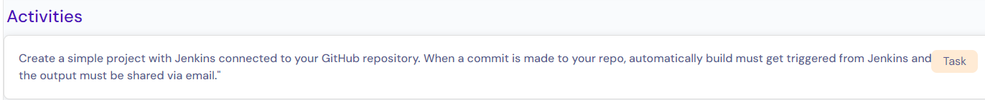

# Pre-condition:

1. Jenkin has been installed.

# Procedure:

1. Repository “**guvidemo**” has been created in github & clone the repository to local PC.

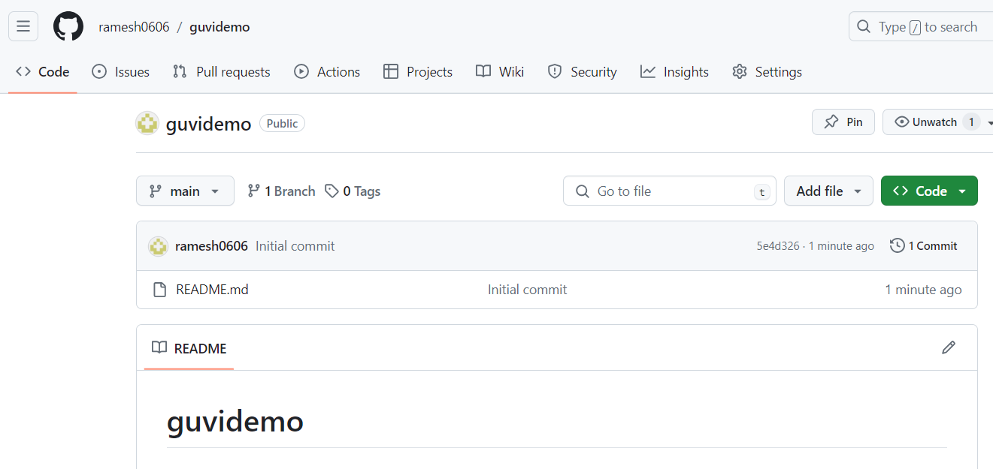

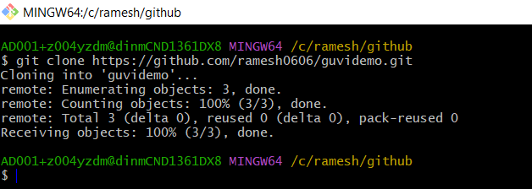

1. Add webhook with URL of your Jenkins server's webhook endpoint in github. This will typically be something like <http://54.183.213.101:8080/github-webhook/>.

Webhook is a github feature whenever any changes taken place in the repository, github triggers a job in the jenkin.

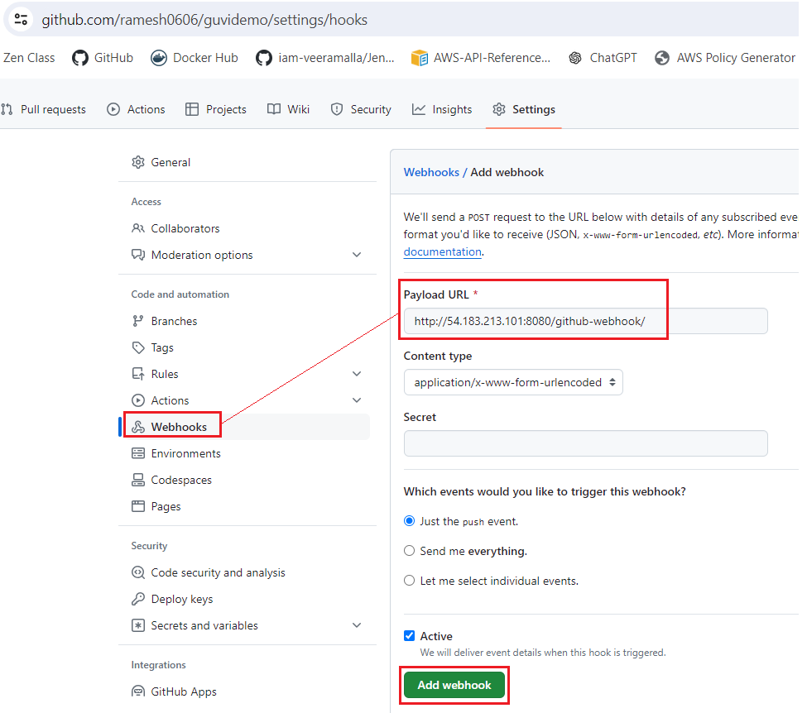

1. **Configure SCM (Source Code Management):**

I created private repository and authenticated with credentials and set branch to **main**.

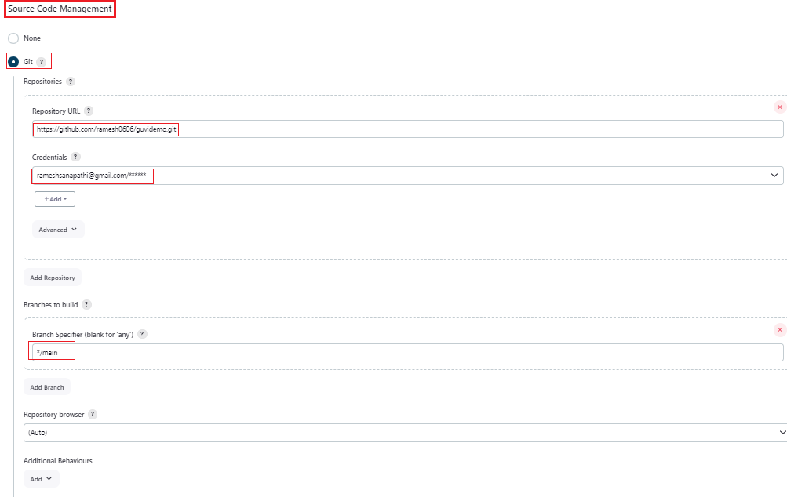

1. **Set Build trigger:**

Select “**GitHub hook trigger for GITScm polling**.” to start a build/job in jenkin whenever any changes push to github repository.

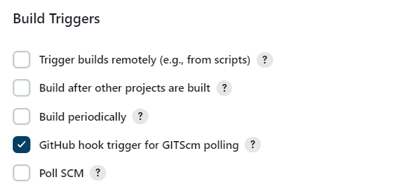

1. **Post-build Actions - Email configuration:**

In post build step, we can choose whether “**E-mail Notification**” or “**Editable Email Notification** “, to send email for configured all recipient emails depends on build condition. Anyhow, we don’t have email server details such as email server IP and port. Hence, we can’t send any email right now, but this is way to configure the recipient email addresses.

**E-mail Notification:**

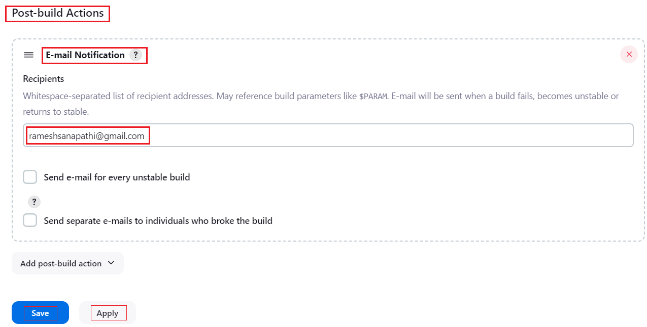

**Editable Email Notification:**

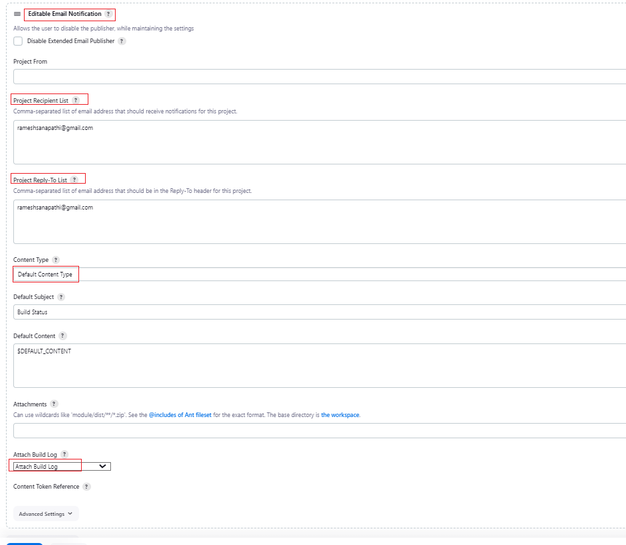

**Verification:**

1. Created one sample .sh file and push to github repository.
2. Github automatically triggers a build in Jenkin.
3. Execute .sh file.
4. Send an email as a post build action.

